**CHAPTER ONE**

**1.1 Introduction:**

The mass development in the computers and internets in the world, And entry in all areas so that has become everything in our world depends on the technology Depending on democracy that prevailed in the country and find election laws in all aspects of life and the election of deputies municipal elections and elections college degree we drew the absence of elected student for college students Jordanian system so that the results are realistic and the fact that the easiest ways .

**1.2** **Problem** **Statement**

Based on the amount of in-depth research on this subject and some polls that we have to find out the problems and difficulties which were represented This was one of the biggest obstacles to these sites electronic and software that rely on programming languages may be slow or unsafe with the difficulty of finding a user interface and easy-to-friend.

**1.3 Project motivation:**

Work of the Website covers all university elections Options so that it is quick and easy to use and The interfaces attractive to users who are university students, and this site will be able to withstand the pressure and congestion which will have it prepared by high students at one time and also I will show reports and the results of the elections efficiently and high speed .

**1.4 Related works:**

In this section, we conduct analysis of some of the software and find the positives and the problems and the work of comparisons between these sites. [1]

**1.4.1 smartmatic**

The site where some elections for the positions of some companies with democracy being of its staff.[2]

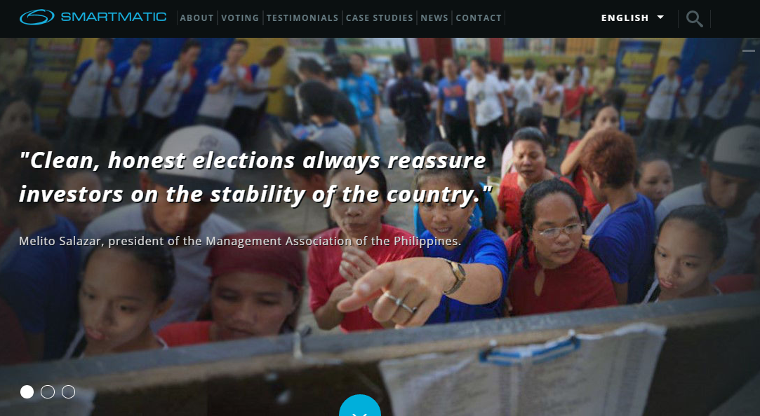

Figure (4 ) : smartmatic

**1.4.2 facebook vote :**

The Facebook company issued a service in order to vote on some of the topics and used some of the university student elections, but the results are hectic is that this system does not appear and there are no reports of privacy.[3]



Figure (3 ) : facebook vote

**1.4.3 twitter vote**

The twitter company issued a service in order to vote on some of the topics and used some of the university student elections, but the results are hectic is that this system does not appear and there are no reports of privacy . [4]



Figure (4 ) : twitter vote

**1.5 Methodologies**

After some previous systems analysis and find the positives and disadvantages and problems we have to develop an action plan for the work site operation be easy for the user and has an all additions

student and teacher of the university mindful of speed beautiful shape, bright colors in order to attract everyone to the site, and then do a test site so that we operations development him and take the feedback student and teacher.[5]

**CHAPTER TOW**

**Requirement and Analysis**

**2.1 Introduction :**

Software design describes the features and operations of the intended application in detail, including screen layouts, business rules, process diagrams, which programs are needed, and how are they going to interact. Within this phase the architectural design, detailed design, interface design, and data design are discussed in depth. Different types of diagrams and models are used to illustrate those designs, as detailed in the following sections.

Requirements engineering (RE) process is the process of determining what the system should provide (functional requirements) in addition to the constraint of the system behaviors (nonfunctional requirements). [6 ]

Many approaches had been followed to collect the requirements of the proposed system. These approaches include:

1. Surveying the literature for similar systems in order to define the functions and facilities that the proposed system should provide. In addition, to determine the weakness in the current systems to be avoided it in the proposed system.

2. Brain storming: many meetings had been conducted among team members to find out some additional functionality that can be provided by the proposed system.

3. We had several discussions with Mr.thaer alzu'bie in JEI company . We gathered from him all the information we needed in this project. We have used his system and detected some errors and problems in the system. On the other hand, we also discussed with the project supervisor Dr. Mahmod baklize on implementing our system and how to manage and integrate the systems process to each other.

**Functional requirements::2.2**

**System Functional Requirements: 2.2.1**

In this proposed project there are many functional requirements as follow:

The system should interact with tow user group; Admin , students.

**2.2.2 : Admin Functional Requirements:**

Administrator is the user who is responsible for configuration of all the system parameter:

1. The system should allow administrator to add new college, slider, specialty, students, users.

2. The system should allow administrator to update college, slider, specialty, students, users.

3. The system should allow administrator to delete college, slider, specialty, students, users.

4. The system should allow administrator to edit college, slider, specialty, students, users.

**2.2.3 : students Functional Requirements:**

The students are certain operations:

1. That the nomination for election
2. That is to vote for candidates

**2.3 Non-Functional requirements**

The non-functional requirements include performance requirement, platform constraints and general system attribute:

**2.3.1 Speed requirements** :

1) Choose the language of high-strength programming and fast.

2) raise Site Host is a large area.

**2.3.2 Security requirements :**

Each system user has different account authorization; only authorized users must login to system to access their own data.

**CHAPTER THREE**

**3.1 Introduction:**

In this chapter we will talk about the designs for the project, which shows us all the operations of the project in order to build the facility in the website.

**3.2 Context Diagram:**

A context diagram is a data flow diagram, with only one big central process that guaranteed everything inside the scope of the system. It shows how the system will receive and send data flowing to the external entities involved, and how the system will deal with process and the actors in the system.[7]

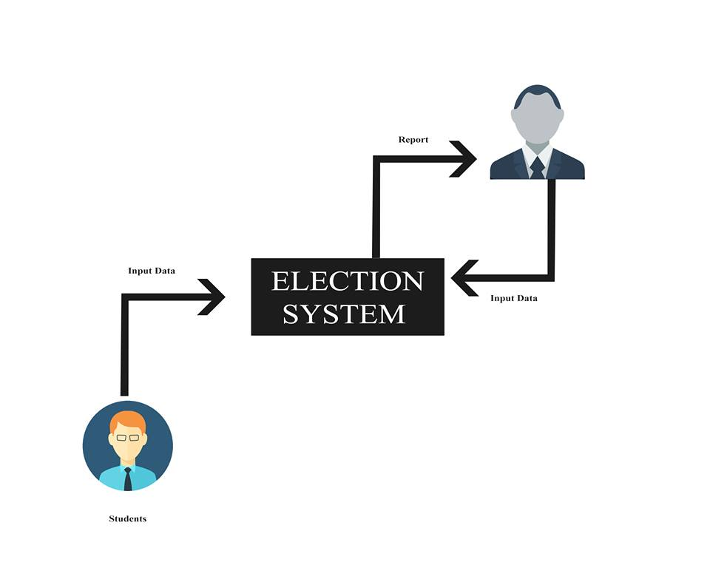

Figure (4) : Context Diagram

**3.3 Use case** :

The use case model shows the main system actors (people who interact directly with the system) to get her with the required functionalities of the proposed system. It also showed the interaction among the actors and the system. [8]

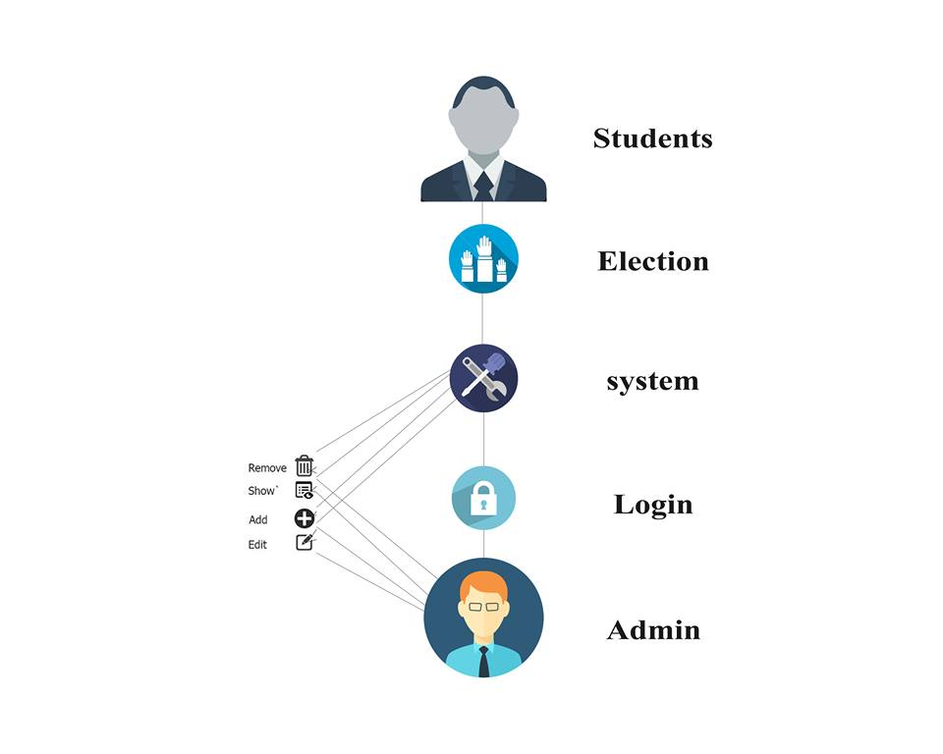

Figure (5 ) : Use case

**3.4 Data Model**

This is the table diagram of the system that shows all tables with attributes and the relation between them.[9]

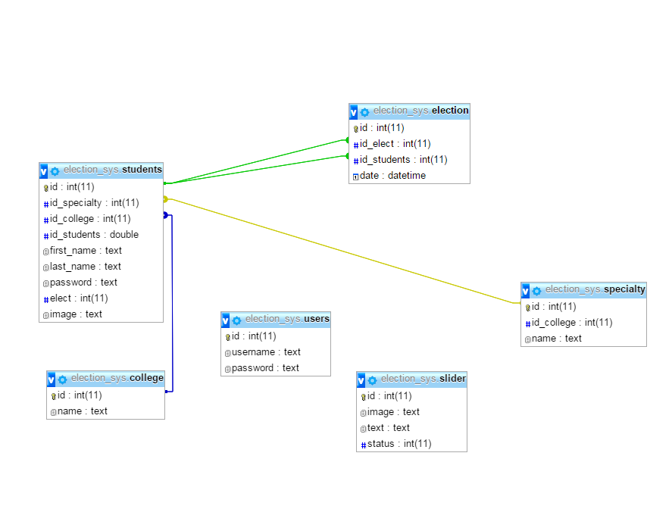

Figure (6 ) : Data model

**3.5 System Main Architecture**

The system architecture represents all external entities that may interact with the proposed system. It shows the hardware, software and user as depicted in figure(7). [10 ]

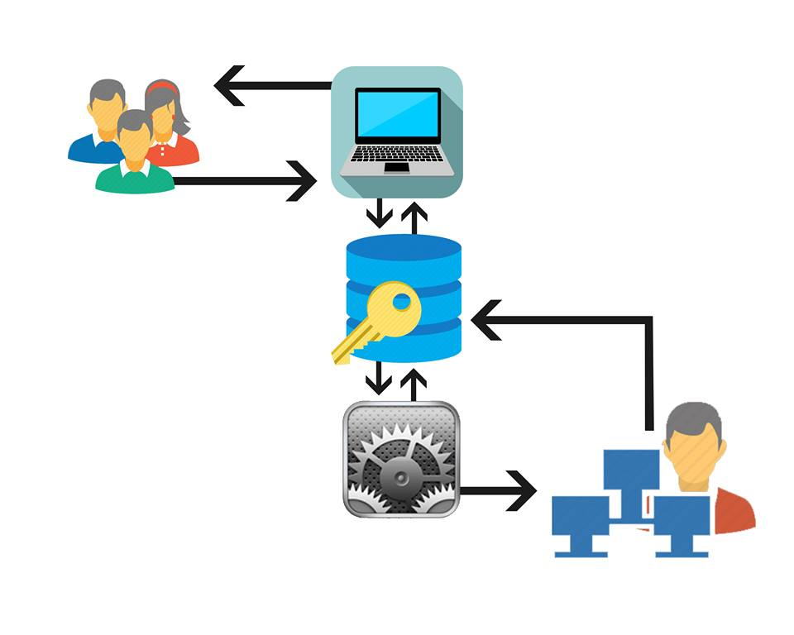

. Figure (7 ) : System Main Architecture

**CHAPTER FOUR**

In this section we show some of the interfaces that were designed at the site and used some of the tables in the database and how to create them .

**4.1 Farms :**

1) Home page : This page that appears to the user starters and have own button animated entry and slide show some candidates' pictures .

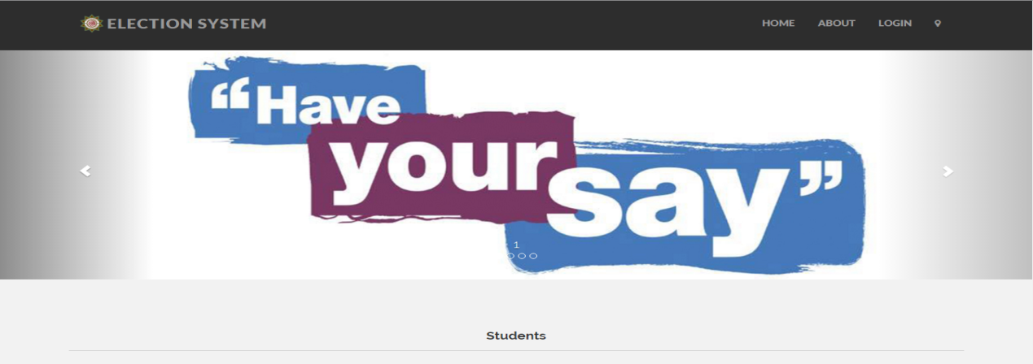

Figure (8) : Home page

2) Login page

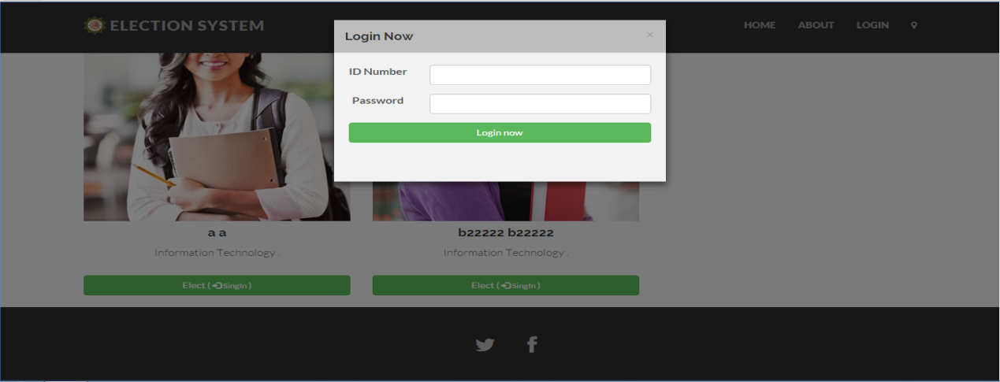

Figur (9 ) : Login page

3) home page students election : This page appears candidates' pictures before entering the site for students

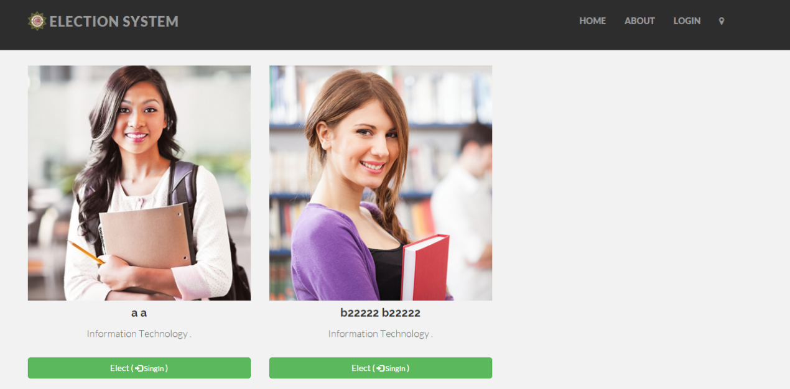

Figur (10) : home page students election

4 ) Map : Shown in this page site map to elections

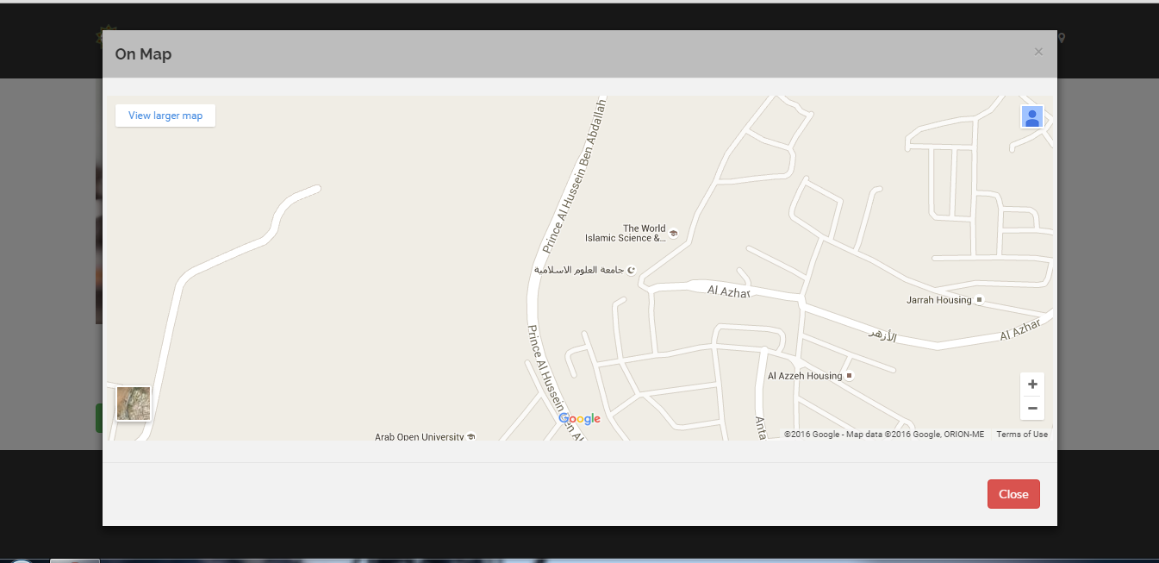

Figur (11) : Map

5) Elect page : After the process of access to the site and when you press the vote in the top of the page shows us a page with pictures of candidates and can vote for them .

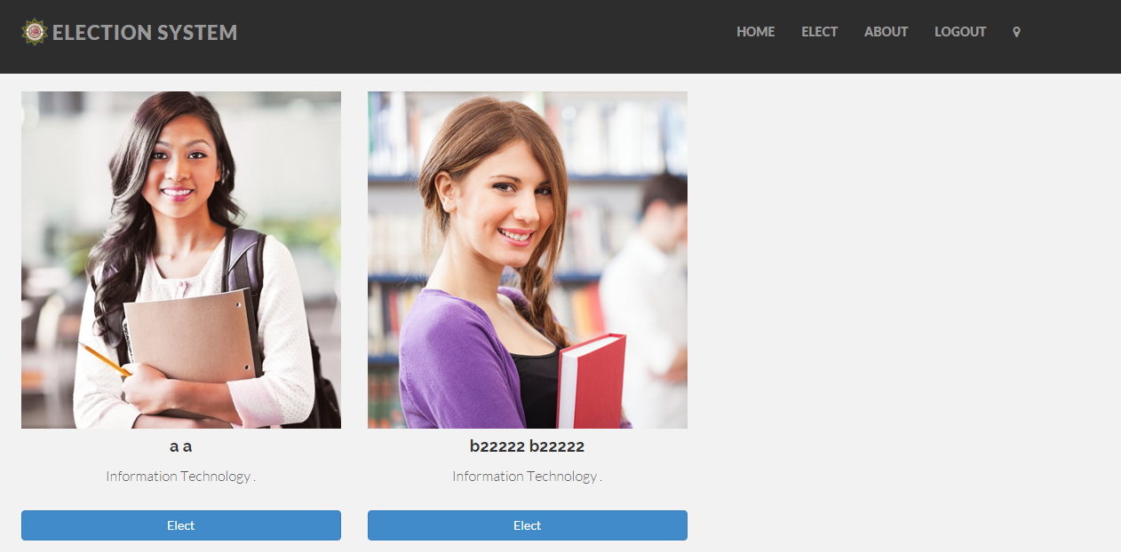

Figur (12 ) : Elect page

6) percentage_elect : Here, the percentage of voters shows how much the amount of votes they obtained .

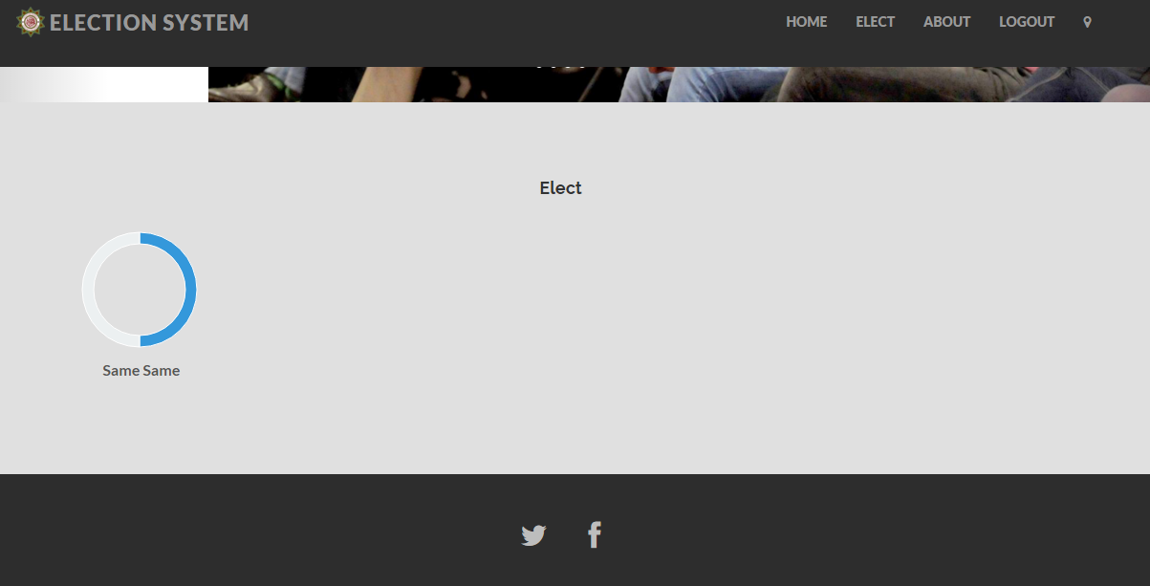

Figur (13 ) : percentage_elect

7) Login Admin : On this page the administrator to enter your user name and password

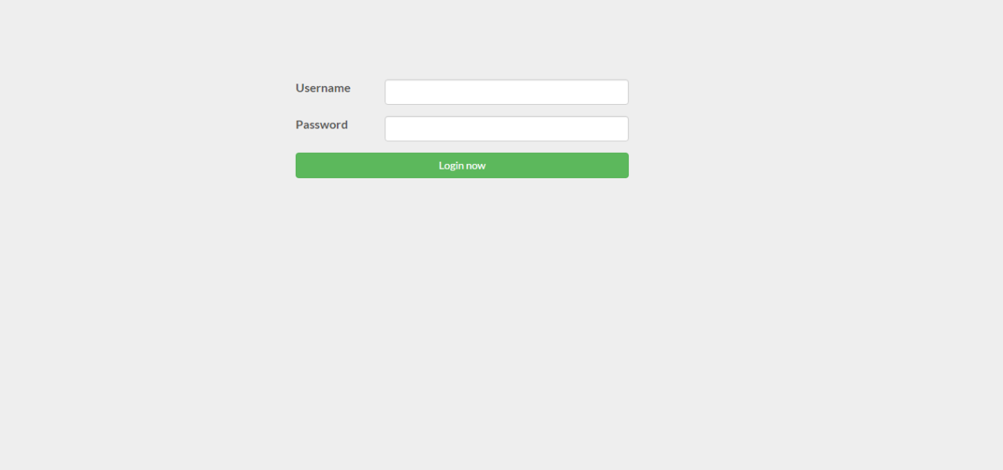

Figur (14 ): Login admin

8) Home page admin : In this page appears addicted to everything about the site and reports on the elections Movement .

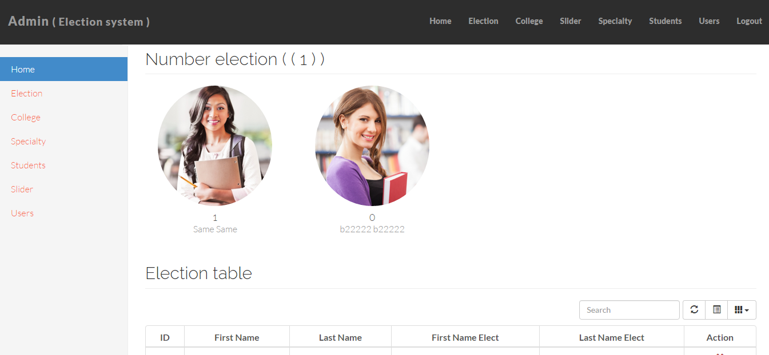

Figur (15 ) ; Home page admin

9) college page : This page appears in our colleges and the administrator can modify them and delete and edit College

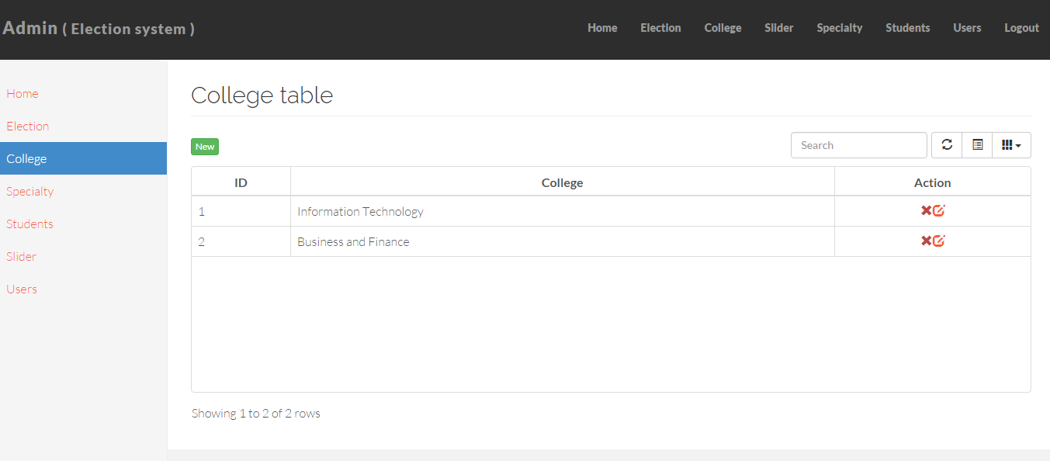

Figur (17 ) : collge page

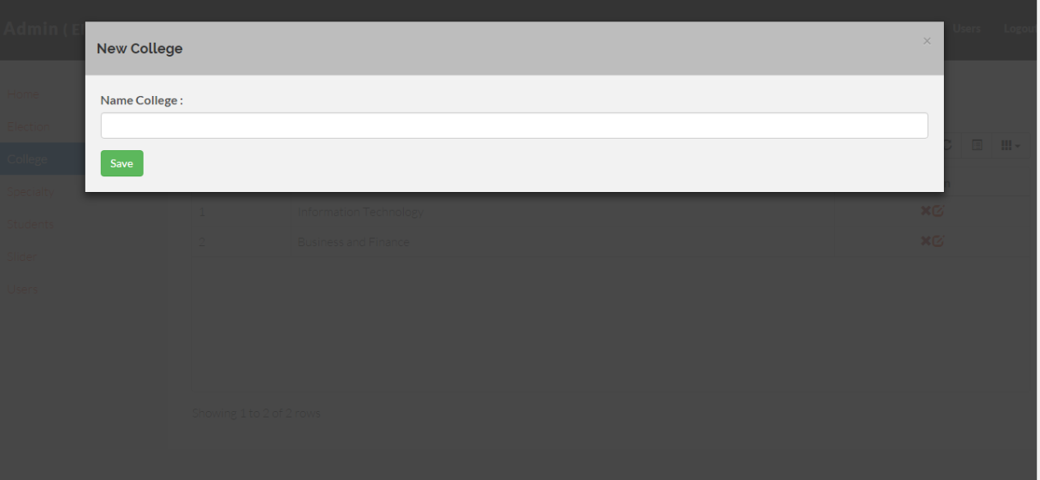

Figur (18 ) :new collge page

10 ) specialty page : This page appears in our specialties and the administrator can modify them and add or delete and edit specialty .

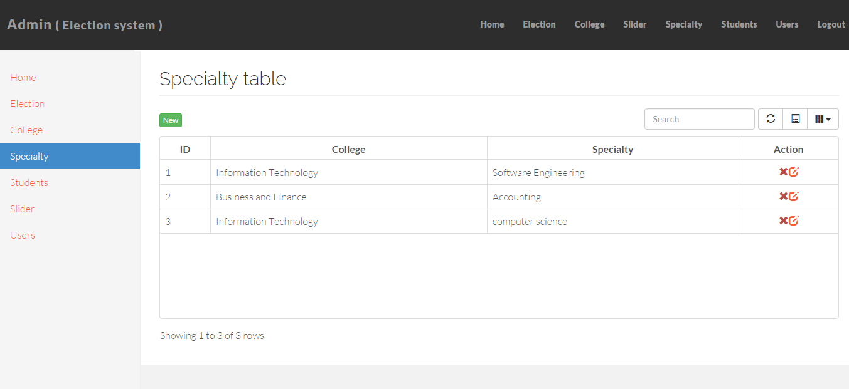

Figur (19 ) : specialty page

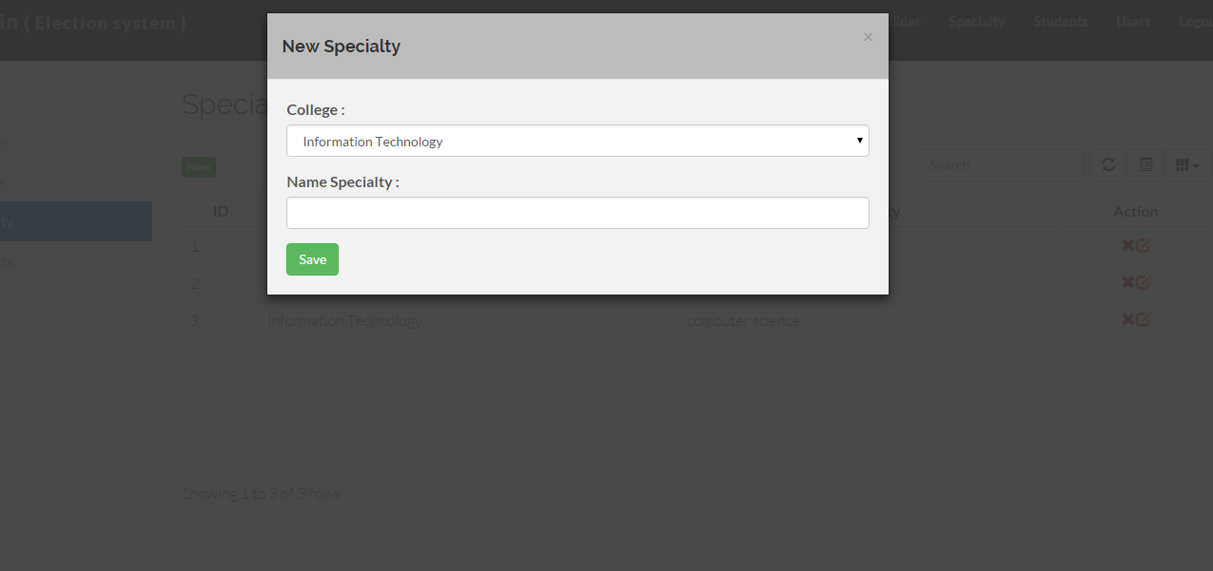

Figure (20 ) : new specialty page

11 ) Students page Admin : This page appears in our Students and the administrator can modify them and add or delete and edit Students .

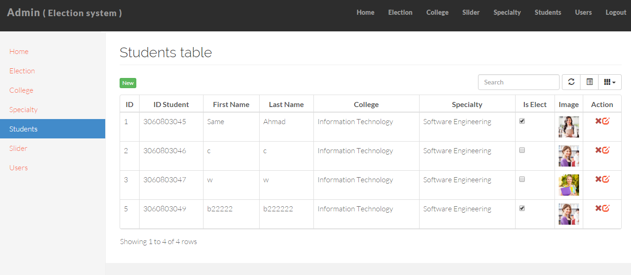

Figure (21 ) : Students page Admin

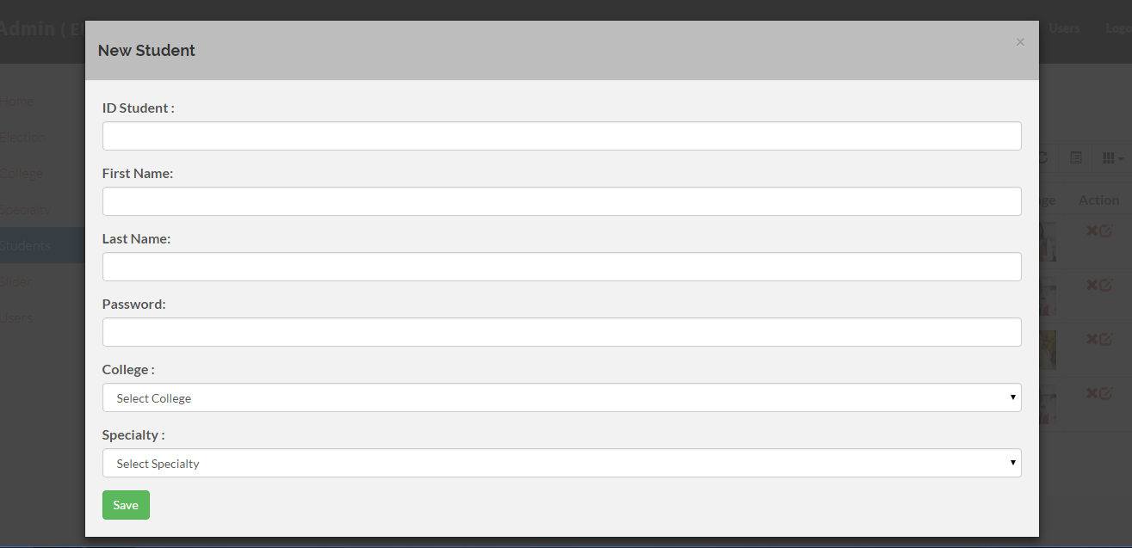

Figure ( 22) : new Students page Admin

12 ) Slider page Admin : This page appears in our slider and the administrator can modify them and add or delete and edit slider .

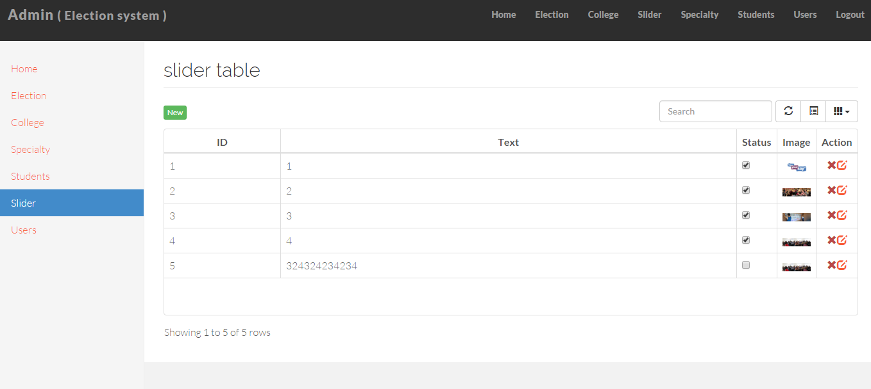

Figure (23 ) : slider page Admin

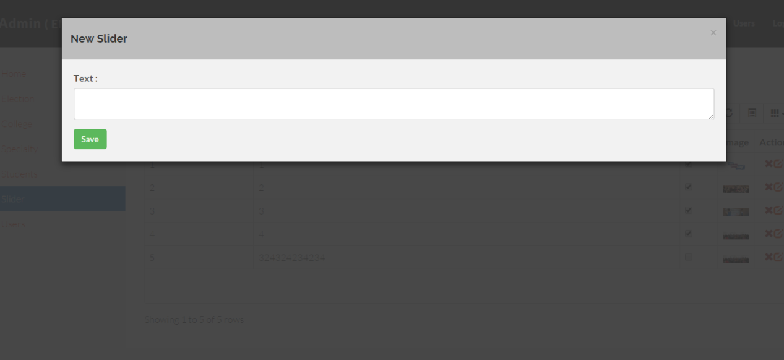

Figure (24 ) : new slider page Admin

13 ) election page : This page shows us the candidate information, data and from which a candidate Add, delete or edit

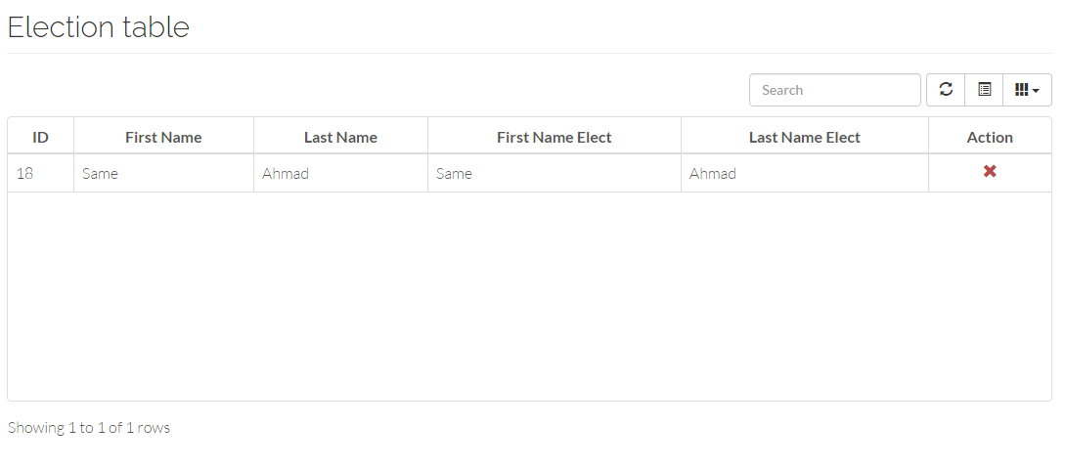

Figure (25 ) : election page Admin

14) user admin page : This page appears in our user and the administrator can modify them and add or delete and edit user.

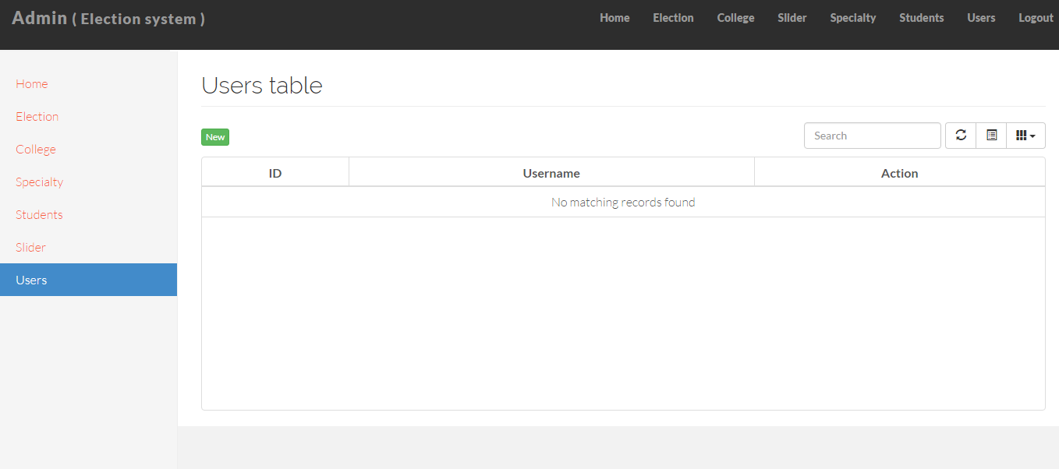

Figure ( 26) : user page Admin

15 ) uplode image students :

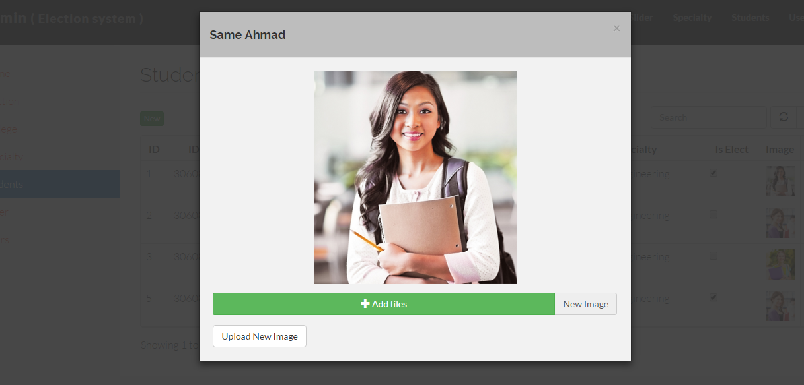

Figure (27 ) : upload image students

**4.1 database table :**

1) Table of college :

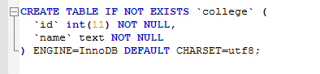

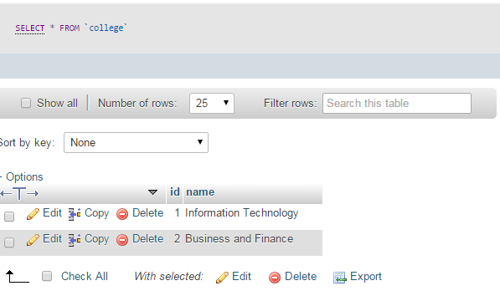

Table (1): college

2 ) Table of election :

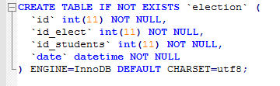

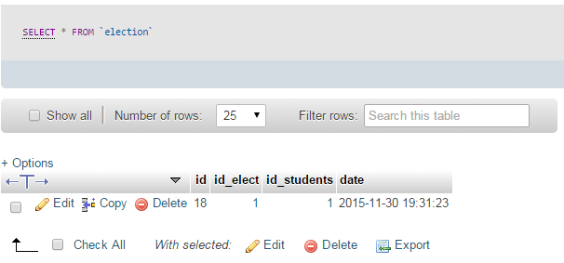

Table (2): election

3) table of slider :

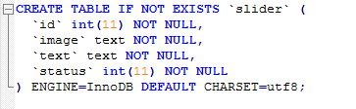

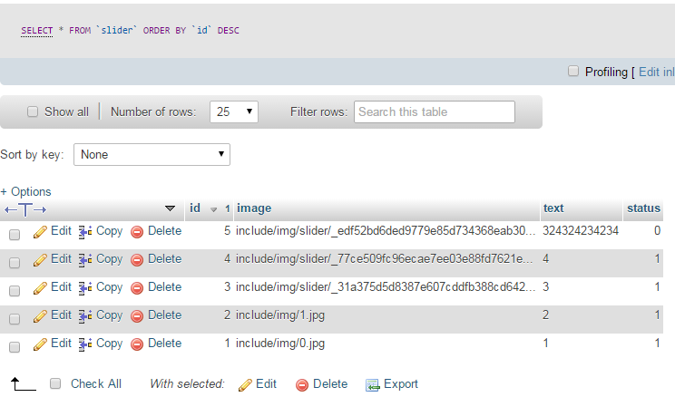

Table (3 ) : slider

4) Table of specialty :

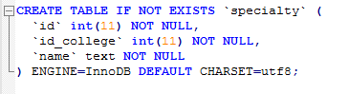

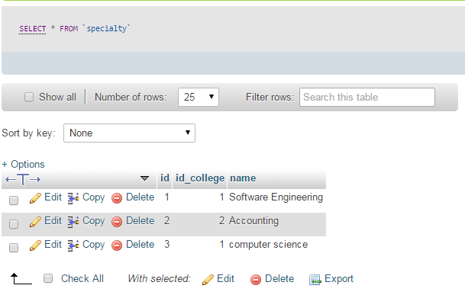

Table (4 ) : specialty

5) Table of students :

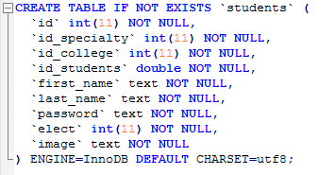

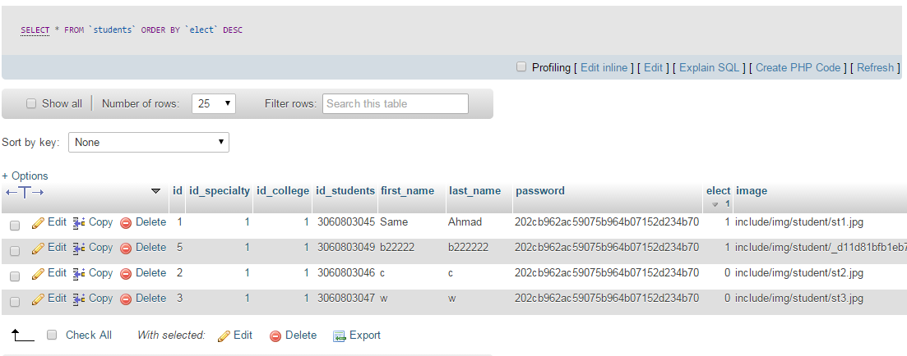

Table (5): Students

6) Table of users :

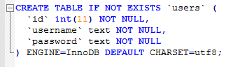

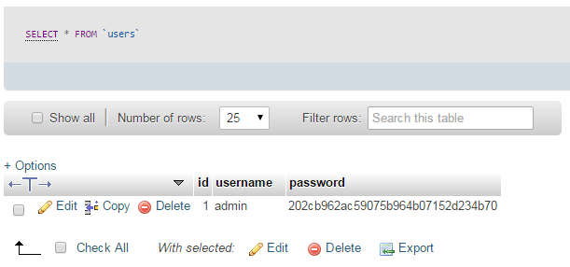

Table (6 ) : user

.

**CHAPTER FIVE**

**5.1 Conclusion**

After the completion of the project after doing a number of studies and find the problems and search for solutions to these problems which were summed up in finding a fast and efficient site and does all operations entrusted to him by the efficiency and create reports and be superior site in speed and easy on the user of the official student With the development of technology that necessitated we have to find ways so that this site will be flexible in terms of the different screens of Laptop Computers and Mobile and Tablet PCs, and after consulting with our expertise we came up with this website.

**5.2 Future Work** :

-Create an application on smart phones for all operating systems so that makes it easier for the customer to use the system.

-Make the site sends newsletters on the latest developments of the situation and electoral events.

**REFERENCES** :

1] <http://cgi.cse.unsw.edu.au/~kevine/thesisguide.html>

2] <http://www.smartmatic.com/>

3] <https://facebook.com/>

4] [https://twitter.com](https://twitter.com/)

5]<https://yuwritingcenter.wikispaces.com/How+to+Write+the+Methodology+of+a+Research+Paper>

6] <https://en.wikipedia.org/wiki/Functional_requirement>

7] <https://en.wikipedia.org/wiki/System_context_diagram>

8] <https://en.wikipedia.org/wiki/Use_case>

9] <https://en.wikipedia.org/wiki/Data_model>

10] <https://en.wikipedia.org/wiki/Systems_architecture>